**Google Ads bid strategies**

Every Google Ads campaign requires a bid strategy, and determining the correct strategy is key for the success of a business campaign with Google Ads.

This reading will discuss bid strategies and the different types you can choose from.

**What is a bid strategy?**

A **bid strategy** is designed to help achieve campaign goals based on budget.

The most basic bid strategy is **Manual Cost Per Click (CPC).** With manual CPC bidding, you set your own maximum cost per click for your ads.

Alternatively, **automated bidding strategies** allow Google Ads to automatically set bids for your ads based on an ad’s likelihood to result in a click or conversion that helps you achieve a specific goal.

**What is Smart Bidding?**

**Smart bidding** is a subset of automated bidding strategies. These strategies use machine learning to optimize for conversions or conversion value with each auction, and they factor in a wide range of auction-time signals such as the user's device, location, time of day, remarketing list, language, and operating system. This means that based on these factors and the context of every search, the bid strategy automatically determines whether or not to bid, and how much to bid.

**Types of bid strategies**

| **Bid Strategy** | **Definition** | **Goal** |
| --- | --- | --- |
| Maximize conversion value | This bid strategy uses advanced machine learning to automatically optimize and set bids. It also offers auction-time bidding capabilities that tailor bids for each auction. | Increase business value |
| Target ROAS | An optional target to maximize conversion value, this bid strategy analyzes and intelligently predicts the value of a potential conversion every time a user searches for products or services you’re advertising. Then, it automatically adjusts your bids for these searches to maximize your return on them. Ideally, this means if the bid strategy determines that a user search is likely to generate a conversion with high value, Target ROAS will bid high on that search. | Increase business value |
| Maximize conversions | Maximize conversions automatically sets bids to help get the most conversions for your campaign within your budget. | Increase sales or leads |
| Maximize clicks | This automated bid strategy sets your bids to help get as many clicks as possible within your budget. | Increase website visitors |
| Target CPA | Target CPA is an optional target to maximize conversions. This bid strategy sets bids for you to get as many conversions (customer actions) as possible. When you create the Target CPA (target cost per action) bid strategy, you set an average cost you'd like to pay for each conversion. | Increase sales or leads |
| Target impression share | There are 3 options for the target impression share strategy, depending on where you want your ads to show: on the absolute top of the page, on the top of the page, or anywhere on the page of Google search results. Google Ads automatically sets your bids to show your ad, based on your placement settings. | Increase awareness and visibility |
| Cost per 1000 impressions (CPM) | With this bid strategy, you'll pay based on the number of impressions (times your ads are shown) that you receive on YouTube or the Google Display Network. | Increase awareness and visibility |
| Cost per view (CPV) | This is the default bid strategy to set the amount you'll pay for video ads in Google Ads. With CPV bidding, you'll pay for video views or interactions. | Increase awareness and visibility |

**Selecting a bid strategy**

While creating a campaign, Google Ads guides you to choose a bid strategy by asking a series of questions to determine your campaign goals. This is useful if you are unfamiliar with specific bidding strategies.

However, the website offers the option to select a bid strategy directly. Once selected, users can choose specific bidding strategies from a drop-down menu.

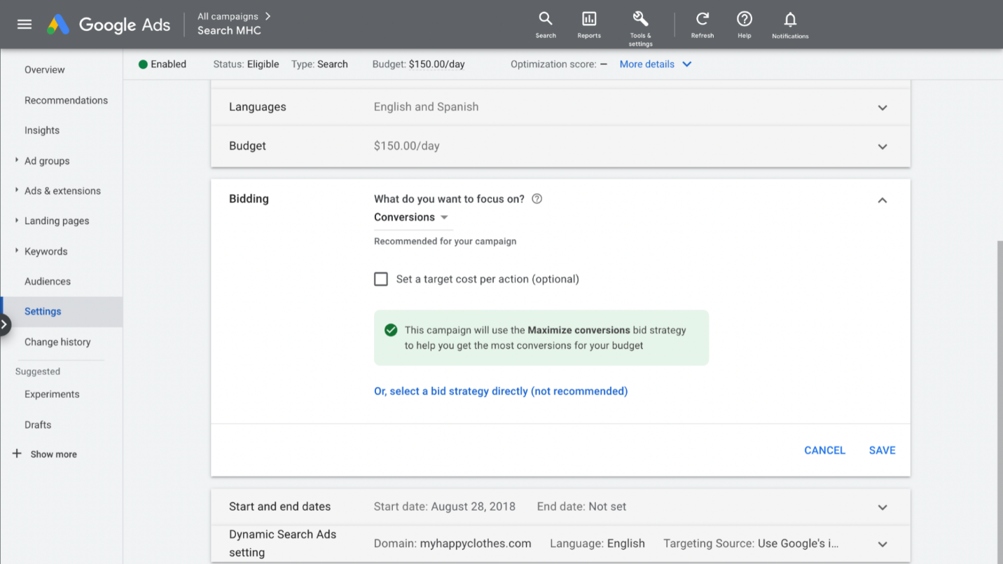

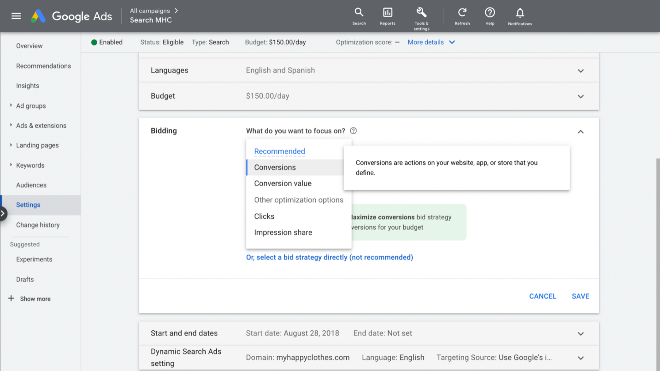

**Key Takeaways**

With so many to choose from, bid strategies can sometimes be confusing to navigate. To make your decision easier, be sure to identify what your goal is first and then match it to the appropriate strategy. Choosing the right strategy often takes trial and error, so don’t worry if your selected strategy doesn’t work initially. You can always apply what you’ve learned from previous attempts to your next campaign.

**Resources for more information**

Choosing the right bid strategy is important for the success of your campaign. For more information on bidding strategies, check out the resources below.

* [Determine a bid strategy based on your goals](https://support.google.com/google-ads/answer/2472725?hl=en#zippy=)
* [Learn more about automated bidding](https://support.google.com/google-ads/answer/2979071?hl=en)